

**Project Management Plan**

MailSpeak (MSA)

University of Maryland Global Campus (UMGC)

Software Engineering (SWEN) 670

Fall Cohort 2022

Team B

November 5, 2022

**Document Control**

**Document Information**

|  | Information |
| --- | --- |
| Document Identification | USPS- MSA-PMP-20220903-Fall2022 |
| Document Owner | UMGC SWEN 670 |
| Issue Date | September 3, 2022 |
| Last Saved Date | November 5, 2022 |
| File Name | PMP-Team B- MSA.docx |

**Document History**

| Version | Issue Date | Changes |
| --- | --- | --- |
| 0.1 | 9/1/2022 | Initial Draft |
| 0.2 | 9/3/2022 | Review Updates |
| 1.0 | 9/3/2022 | Final Deliverable |
| 1.1 | 9/7/2022 | Add Change Control Board Roles |
| 1.2 | 9/11/2022 | Add Risk Evaluation Matrix |
| 1.3 | 9/15/2022 | Add Project Suite of Documents |
| 1.4 | 9/16/2022 | Add Testing Methodology |
| 2.0 | 9/17/2022 | Final Deliverable |
| 2.1 | 10/7/2022 | Logo and name change updates |
| 3.0 | 10/29/2022 | Post-development updates |
| 3.1 | 10/30/2022 | References style and document suite updates |
| 4.0 | 11/5/2022 | Final deliverable |

Approval Signatures

|  |  |  |  |  |
| --- | --- | --- | --- | --- |
| ☐ APPROVE  ☐ DISAPPROVE | |  | | --- | |  | | Tatiana Kozhevnikova, Product Owner  Date: _____________ | |  | |
| ☐ APPROVE  ☐ DISAPPROVE | |  | | --- | |  | | Michael Conatser, Project Manager  Date: _____________ | |

**Table of Contents**

1 Project Information 5

1.1 Purpose 5

1.2 Statement of Need 5

1.3 Vision Statement 6

1.4 Stakeholders 6

1.5 Project Methodology 6

1.6 Project Tools 6

1.7 Project Suite of Documents 7

2 Scope Management 7

2.1 Scope 7

2.2 Work Breakdown Structure (WBS) 9

2.3 Deployment Plan 9

2.4 Change Control Management 9

2.4.1 External Change Requests 9

2.4.2 Internal Change Requests 10

2.5 Resources 10

3 Time Management 11

3.1 Schedule 11

3.2 Milestones 0

3.3 Phases 1

3.4 Dependencies 1

3.5 Assumptions and Constraints 2

4 Cost Management 3

5 Quality Management 3

5.1 Code 4

5.2 Documentation 4

5.3 Software 4

6 Staffing Management 4

7 Communications Management 5

7.1 Microsoft Teams 6

7.2 GitHub 7

7.3 Email 7

8 Risk Management 7

8.1 Risk Analysis 8

8.2 Issue Management 9

9 Compliance Related Planning 10

Appendix A - Acronyms and Definitions 11

Appendix B – Detailed Project Schedule 12

Appendix C - Risk Register 17

Appendix D - References 18

# Project Information

The United States Postal Service (USPS) is an agency that transports mail to and from residential customers. To better assist their customers, the USPS offers a free subscription service called Informed Delivery that allows users to receive images of the mail incoming 7 days a week. The service even allows senders of mail items to associate advertisements via their campaign feature, replace black and white images of mail with full-color photos, and show packages arriving within the next week as well as outbound.

To extend the Informed Delivery service’s capabilities, USPS has requested a set of features to be implemented via an external application that will allow customers to be able to consume and interact with this service even further. The application is meant to run on mobile devices and will allow voice commands to find mail items as well as alerts to trigger when items are received. Overall, the application shall focus on enabling users with visual impairments to more effectively achieve their goals than by using a standard email client.

## Purpose

The intended audience of the Mail Speak Application Project Management Plan (PMP) is all project stakeholders including the project sponsor, senior leadership, and the project team. The purpose of this PMP is to communicate to the project team and stakeholders the specific procedures that the Mail Speak Application project team will follow throughout the project lifecycle. All tasks under Mail Speak Application shall adhere to this plan. This plan was developed based on guidance provided by the customer, program manager, and project mentor to expand upon the existing MSA to be more widely usable.

Information provided in this PMP is determined by University of Maryland Global Campus (UMGC) Software Engineering (SWEN) 670 Fall 2022 Cohort Team B, all decisions/clarifications will be discussed and agreed to by Mail Speak Application stakeholders. The PMP is to be used as a mechanism for the project management team to document how the Mail Speak Application project team will create deliverables, as well as the entry and exit (acceptance) criteria and approach for each deliverable. The PMP will be revisited for possible revision or updates when any of the following conditions occur:

1. A major shift in project direction is experienced (e.g., direction from client)
2. A major process change is implemented to the overall project lifecycle thus requiring a change to the lifecycle implementation area and requiring training for all team members
3. Key personnel changes
4. A significant change in the project scope or funding occurs
5. Revisit it annually once we enter the Operation and Maintenance phase for the MSA system

The PMP is not a project schedule. The project schedule will list planned dates for performing tasks and activities to meet milestones identified within this project plan.

## Statement of Need

The purpose of extending the functionality of the existing Mail Speak Application is to refine the User Interface (UI) for non-visually impaired users and extend the functionality for all users. This will increase the capabilities of the Informed Delivery Daily Digest service by allowing notification triggers, easier search features, data collection, and more. While expanding the feature set of the current application, the team must continue supporting visually impaired users as the primary focus.

The result of this project will position the Mail Speak Application to be much closer to an end user product. While a production release is outside the scope of this project, each iteration helps the project get closer to that end goal of a USPS production-ready application.

## Vision Statement

The vision for this project is to enhance the already robust capabilities of the Mail Speak Application to better assist all users to ensure they can successfully find their mail items as easily as possible.

## Stakeholders

The Project Management Plan will provide project stakeholders and partners with information sufficient to ensure their effective participation in the decision-making process; a major risk mitigation strategy in and of itself. Stakeholders are the people and organizations that can influence, or are influenced by, the outcome of the project. Stakeholders include signatories, customers, sponsors, project team members, independent testers, certifying organizations, external parties, and others with a vested interest in the project outcome.

Table 1.1 - Projects Points of Contact

| Stakeholder Name | Project Role |
| --- | --- |
| Mir Assadullah | Professor, Program Manager |
| Roy Gordon | Project Mentor |
| Robert Wilson | DevSecOps Mentor |
| Robert Dixon | Project Sponsor |
| Alexander Chan | Software Engineer (SE) II |
| Andrew Asavarungsrikul | Software Engineer (SE) I |
| Erin Sauter | Software Engineer (SE) I |
| Jonay Simmons | Software Engineer (SE) I |
| Lawrence Van Tassel | Software Engineer (SE) III |
| Michael Conatser | Project Manager (PM), Scrum Master |
| Minyahil Kebebegn | SE II |
| Sarah Johnson | SE I |
| Shane Knowles | DevSecOps Engineer (Principal) |
| Tatiana Kozhevnikova | Product Owner |
| TraMel Perry | Principal Software Engineer (SE) |

## Project Methodology

This project will follow the Agile Scrum Software Methodology as the development team will perform daily standups, backlog refinement, and sprint planning when development begins. The core Agile Scrum principles are control over the process (embracing change), self-organization, collaboration, prioritization, and iterative development. This process works exceptionally well with the short deadline of this project and the need to incorporate customer feedback as it is learned throughout development.

## Project Tools

The following software tools will be utilized by team members for the development and execution of this project:

Table 1.2 - Project Tools

| Name | Description | Version |
| --- | --- | --- |
| Android Studio | Integrated development environment | 2021.2.1 (Chipmunk) |
| Diagrams.net/Diagrams.io | Online version of the open source technology stack for building diagramming applications | 16.4.5 |
| GitHub | Online version control, repository, and collaboration platform | 3.6.1 |
| GitHub Desktop | GitHub interface application | 3.0.7 |
| Microsoft (MS) 365 | Suite of applications including word processing, project planning, and presentation software | 2208 (Build 15601.20088) |
| Microsoft (MS) Teams | Communication and collaboration platform | 1.5.00.21551 |
| Microsoft (MS) Project | Project management tool to assist with scheduling | 2019 |

## Project Suite of Documents

This Project Management Plan is part of a set of essential documents created to adequately manage, control and deliver the MSA. Artifacts that are provided within the document package contain vital information for the application’s ongoing support and operation throughout its life cycle. Each document is created within the specific Milestone of the project. Therefore, the version and date of some documents could be marked as “to be determined” (TBD) in Table 1.3.

Table 1.3 - Project Documentation Package

| Document | Version | Date |
| --- | --- | --- |
| Project Management Plan | 4.0 | 11/05/2022 |
| Software Requirements Specification | 4.0 | 11/05/2022 |
| Technical Design Document | 3.0 | 11/05/2022 |
| Software Test Plan | 3.0 | 11/05/2022 |
| Programmer Guide | 2.0 | 11/05/2022 |
| Development and Operations Guide | 2.0 | 11/05/2022 |
| User Guide | 1.0 | 11/05/2022 |
| Test Report | 1.0 | 11/05/2022 |

# Scope Management

## Scope

The project scope entails taking an existing application tailored for visually impaired users and extending its functionality to better accommodate impaired and non-impaired users. The USPS wants a better user interface as well as more accessibility features, enhanced search, enhanced mail view, notifications, internal feedback, chatbot, and voice assistance.

This set of features will be divided amongst two teams and completed in unison with separate deliverables and presentations. This project plan and accommodating documentation pertains to the work to be completed by Team B. Acquisition of any licenses or subscriptions required for the public release of this application is not within the scope of this project.

The current software for the USPS Mail Speak Application has been developed using Flutter to allow cross-platform development for Android and iOS devices.

**The scope of the project to be handled under Team B:**

**Accessibility**

* Gesture and Voice driven for all features of MSA
* Read screen functions and content for visually impaired users across all features of MSA

**Search View**

* Search for past mail/email for a specified date range, sender, or keywords
* Store object character recognition (OCR) content of mailing card images for more performant search
* Provide feedback to USPS on searches conducted providing marketing support

**Chatbot**

* Chatbot feature is added to MSA
* Chatbot to provide access to all features of MSA

**Out of scope for this project. The following items will be handled under Team A:**

**Mail View**

* Open resulting email from search
* Call, email, or send text message to sender or contact on command
* Visit links or barcodes within a piece of mail
* Provide feedback to USPS on the links or barcodes visited

**Notifications View**

* Look out for email from a sender or keyword

**Internal Feedback**

* Research cyclic consumer behavior to report to USPS and its customers

**Voice Assistant**

* Integrate with Google Assistant and Siri to initiate all possible MSA functions

## Work Breakdown Structure (WBS)

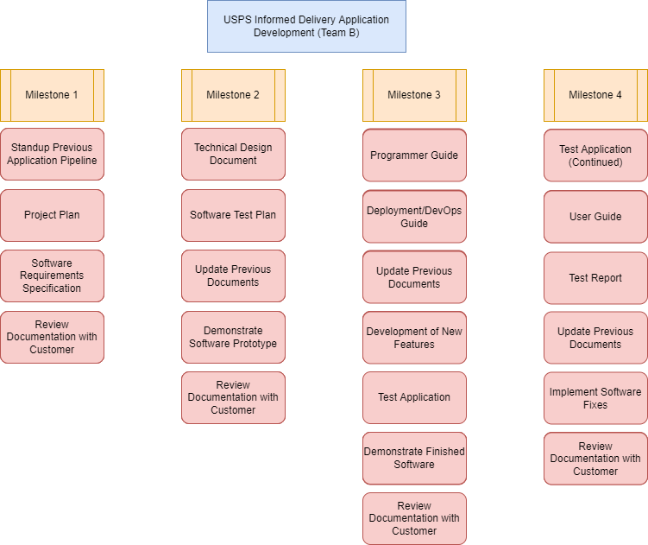

Figure 2.1 - Work Breakdown Structure

## Deployment Plan

A Deployment Plan will be developed during the second Milestone and provide detailed instructions for how to build and distribute the application for iOS and Android platforms. As this software is open source, the repositories will remain in GitHub for anyone to view and use the code as needed. Acquisition of the necessary licenses and subscriptions required for publishing the application to these platforms is not within the scope of this project, but artifacts to be published to these environments will be generated as part of the build pipelines.

## Change Control Management

### External Change Requests

As new requirements changes are received from the customer, the requirements will be evaluated for viability within the team. If the project team determines that the change request can be accommodated within the current schedule of the project, it will be accepted. If it is expected to cause a schedule slip, discussion will occur with the customer to determine if it should replace other project requirements. Once accepted, the Project Manager and Product Owners will determine team ownership. The team responsible will update their requirements documentation and make adjustments to their schedule to incorporate the new tasks.

### Internal Change Requests

If change requests to the established plan or requirements are recommended from within the project team, the input will be collected and discussed internally for need and viability. Once approved internally by the Project Manager and Product Owners, the change request will be discussed with the customer for approval during the weekly Customer Sync meeting. Meeting may be conducted via email as schedules require.

In this meeting, the Change Control Board (CCB) will give the final decision on how this change should be integrated into the end product and may result in a change in other requirements. The CCB will include:

* The project Manager will act as a change manager, who explains the importance of a change, documents a change management process and plans for change implementation; also, coordinates and oversees all aspects of a change within the project team.
* The project Sponsor and Program Manager will act as approvers, who will authorize or reject the change.

If the team feels that the need is urgent, it will be discussed with the Project Sponsor prior to the weekly meeting.

After being accepted by the customer, the change request is treated as an External Change Request from this point.

## Resources

For each task identified, list the resources allocated to complete the task.

Table 2.1 - Resources Assigned to Tasks

| Task© | Resource |
| --- | --- |
| Stand-up Previous Application Pipeline | Software Engineer  DevSecOps Engineer |
| Project Plan | Product Owner  Software Engineer |
| Software Requirements Specification | Software Engineer |
| Technical Design Document | Software Engineer |
| Software Test Plan | Software Tester |
| Demonstrate Software Prototype | Software Engineer |
| Programmer Guide | Software Engineer  DevSecOps Engineer |
| Deployment and Operations Guide | DevSecOps Engineer |
| Development of New Features | Software Engineer |
| Testing of Features | Software Tester |
| Demonstration of Finished Software | Software Engineer  Product Owner |
| User Guide | Software Engineer  Software Tester  Product Owner |
| Test Report | Software Tester |
| Implement Software Fixes | Software Engineer |
| Review Documentation with Customer | Project Manager  Product Owner |

# Time Management

## Schedule

Below is a summary schedule for the project.

Figure 3.1 - Project Schedule

Note: Refer to Appendix B for a detailed project schedule.

## Milestones

Milestones are significant events within the project schedule and are dependent on the scope and project deliverables. Additional internal milestones may be imposed by USPS Informed Delivery Enhancement project manager during activity sequencing or schedule development as checkpoints to help control the project. Appendix B contains the Microsoft Project schedule that contains the WBS and major milestones for the project.

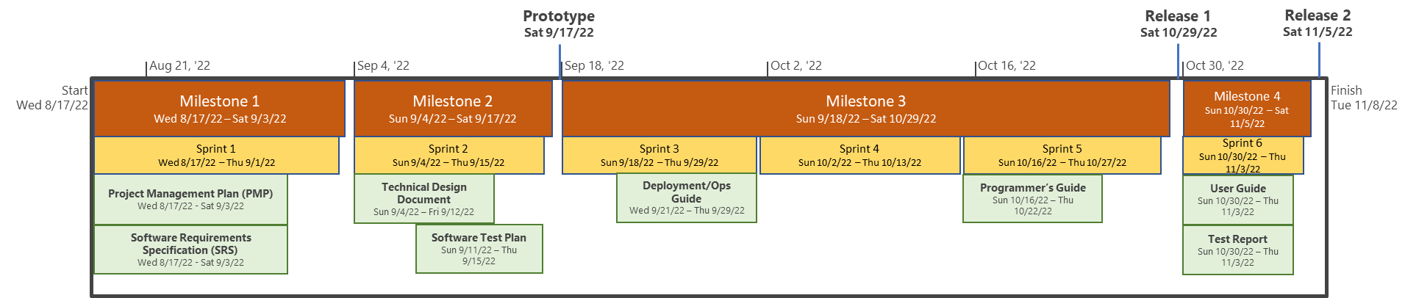Figure 3.2 - Quick Reference Project Schedule

A *milestone* is “a major event in the project” and represents the completion of a set of activities.

Table 3.1 - Milestones

| Milestone | **Artifact** | Description | Delivery Date |
| --- | --- | --- | --- |
| **Milestone 1** | | | |
| 1 | Establish Development Environment | Successfully set up development environment. | 9/3/2022 |
| 1 | Project Management Plan (PMP) | Project Plan completed and approved. | 9/3/2022 |
| 1 | Software Requirements Specification (SRS) | Software Requirements Specification created and published. | 9/3/2022 |
| 1 | Documentation Review | Review of previous project documentation and new documentation for accuracy and submission | 9/3/2022 |
| **Milestone 2** | | | |
| 2 | Technical Design Document | Technical Design Document completed and approved. | 9/17/2022 |
| 2 | Software Test Plan | Software Test Plan completed and approved. | 9/17/2022 |
| 2 | Update Documents | Project documents from previous milestone updated for project changes and additions. | 9/17/2022 |
| 2 | Prototype Completion | Proof of Concept provided as prototype of approved enhancements. | 9/17/2022 |
| 2 | Documentation Review | Project documentation reviewed for accuracy for submission. | 9/17/2022 |
| **Milestone 3** | | | |
| 3 | Programmer Guide | Programmer’s Guide completed and approved. | 10/29/2022 |
| 3 | Deployment and Operations Guide | Deployment and Operations Guide completed and approved. | 10/29/2022 |
| 3 | Update Documents | Project documents from previous milestones updated for project changes and additions. | 10/29/2022 |
| 3 | Enhancement Development | Development of approved enhancement and issue fixes in existing solution. | 10/29/2022 |
| 3 | Version 1 (V1) Test | Testing of delivered development effort supporting requirements identified in approved SRS. | 10/29/2022 |
| 3 | Deploy/Demonstration V1 | Implement and provide demonstration of developed solution for V1. Release product to App Stores. | 10/29/2022 |
| 3 | Document Review | Project documentation reviewed for accuracy for submission. | 10/29/2022 |
| **Milestone 4** | | | |
| 4 | User Guide | User’s Guide completed and approved. | 11/5/2022 |
| 4 | Test Report | Test Report completed and approved. | 11/5/2022 |
| 4 | Update Documents | Project documents from previous milestones updated for project changes and additions for final submission. | 11/5/2022 |
| 4 | Issue Mitigation | Development of approved issue fixes in solution. | 11/5/2022 |
| 4 | Version 2 (V2) Test | Testing of delivered mitigated approved issues. | 11/5/2022 |
| 4 | Deploy/Demonstration V2 | Implement and provide demonstration of developed solution for V2. Release product update to App Stores. | 11/5/2022 |
| 4 | Document Review | Project documentation reviewed for accuracy for final submission. | 11/5/2022 |

## Phases

Listed below are the major project phases and key tasks defining each phase of work.

Table 3.2 - Project Phases

| Phase | Description© |
| --- | --- |
| Project Initiation | Project Charter, Team Assignments, Stakeholder Analysis, Kick-off meeting |
| Project Planning | Project Management Plan, Task Planning, Risk Identification, Communication, Scheduling, Software Requirement Specification, Earned Value Analysis |
| Project Execution | Manage Agile – Software Development Lifecycle (A-SDLC) process, Project Development Deliverables, Change Process, Issue Log, Risk Register, Monitor Control, Demonstrations |
| Project Closure | Deliver Final Deliverables, Deliver Final Code Base, Final Demonstration |

## Dependencies

The MSA PM will develop the Integrated Master Schedule (IMS) from detailed work elements in the WBS and arranged with the appropriate tasks inter-dependencies. The IMS provides an up-to-date picture of the status of all ongoing tasks and potential resources requirements of upcoming tasks. The MSA IMS will track project components such as metrics, timelines, requirements, personnel, and deliverables. The project team will pull resources, broker skills, and use program management best practices to create efficiencies. The MSA PM will create and maintain the IMS in Microsoft Project and will also maintain task management using Project function provided in GitHub repository.

* Internal Schedule Dependencies
  + Successful completion of artifacts in each milestone must be at an 80% completion rate to successfully move to the next milestone.
  + Agile System Development Life Cycle (A-SDLC) phases must happen in the following order.
    - Initiation
    - Planning
    - Execution
    - Closure
  + Completed requirements
    - Completed requirements will allow the MSA team to understand the full scope of the system affected by the project.
* External Schedule Dependencies
  + Client approval of the proposed enhancements before development begins
  + Appointment of project teams must be defined early enough to allow the team to meet concrete milestones
  + Successful integration of existing code base
  + Communication and cooperation of requirements being executed by partner team
* Discretionary Dependencies
  + Will be fully documented and will be available in future revisions.

## Assumptions and Constraints

The assumptions and constraints listed in Table 3.3 below are presented as a basis for project planning and execution and will be evaluated throughout the project lifecycle. It is understood that changes to the assumptions and constraints listed here could result in a change in the project scope, adversely affect cost and schedule, or result in unexpected technical challenges or risks.

Table 3.3 - Assumptions and Constraints

| Category | Items |
| --- | --- |
| Assumptions | * It is understood by the customer and project team that the baseline for this project is the final result of the Summer 2022 section of the SWEN 670 Capstone course. All requirements and documentation will be built as standalone updates based on what has already been completed. * Application code will be hosted and evaluated by the customer in GitHub, and deliverable documents will be uploaded to the UMGC SWEN 670 course page * Application will be supported on the Android and iOS operating systems. * Baseline code from previous cohort has base functionality identified in delivered software requirements documentation. * Team will have the required skills to provide subject matter expertise in all areas of the software development lifecycle. |
| Constraints | * Development will be done using the Flutter framework using the Dart programming language. * Work will be delivered to the customer at four fixed milestones as indicated in the “Milestones” section. These milestones cannot be adjusted except by the customer. The only work delivered outside of these milestones will be the weekly Earned Value Management (EVM) reports. * Condensed development cycle will affect ability to provide fully implemented solution. |

# Cost Management

Team B's Cost management plan provides the cost for the project resources over its life cycle. It also effectively manages and controls the project to be in alignment with cost baseline along with managing schedule variances. This cost plan is based on the resource planning that is required to execute the project and take it to completion. The resources are assumed to be available for 11 weeks and each resource is expected to execute their assigned task at least for 3 hours each day.

For this project, Team B members will use their personal hardware and provided software to build the application. All members in Team B will devote a set number of work hours every day in order to complete the project in 11 weeks. The table below shows the predicted total hours and cost breakdown based on past project costs and salaries retrieved in August 2022 from salary aggregation website levels.fyi for employees of Amazon. In the cost breakdown shown below the team members are assumed to work for 3 hours per day for 11 weeks.

**Note:** Total Hours = 10 hours per resource/week * 11 weeks * 11 resources

Table 4.1 - Resources Hourly Rate

| Resources | Hourly Rate | Hours/Week | # of resources | Total Cost |
| --- | --- | --- | --- | --- |
| Project Manager | $46/hour | 10 Hours | 1 | $5,060.00 |
| Product Owner | $62/hour | 10 Hours | 1 | $6,820.00 |
| Principal SE | $90/hour | 10 Hours | 2 | $19,800.00 |
| Software Engineer III | $83/hour | 10 Hours | 1 | $9,130.00 |
| Software Engineer II | $75/hour | 10 Hours | 2 | $16,500.00 |
| Software Engineer I | $62/hour | 10 Hours | 4 | $27,280.00 |
|  | **Total Hours** | 1210 Hours | 11 | $84,590.00 |

The estimated costs for procuring required licenses and subscriptions are as follows:

Table 4.2 - Licenses and Subscriptions

| License/Subscription | Price | Renewal Rate | Justification |
| --- | --- | --- | --- |
| Android Play Store | $25 | N/A | Allows the product to be available through the Android Play Store |
| Apple App Store | $99 | Annually | Allows the product to be available through the Apple App Store |
| Google Cloud Vision Artificial Intelligence (AI) | $1.50/1000 units  (after first 1000 units processed in current month) | Monthly | Allows the product to perform image processing for mail pieces |

# Quality Management

The MSA project will be managed using best practices standards for quality assurance by introducing controls, reviews, and monitoring. Policies and procedures will be utilized in alignment with customer requirements in order to ensure the project meets its defined objectives. Industry best practices shall be used to evaluate benchmarks, performance metrics, and Key Performance Indicators (KPIs) as a part of our quality control planning.

Appropriate performance metrics will be proposed as a part of the process in negotiating a performance baseline and will consider the MSA project objectives, system performance objectives, and industry benchmarks. Performance is tied to accountability throughout the process. After performance standards are established with the customer the project team will monitor, measure, and analyze performance and include these metrics in the project test report.

## Code

Code quality will be managed through a pull-request review process before any code changes are integrated into the development baseline. Two reviewers must approve each software change, but can also provide suggestions for improvement or can reject the pull-request if it does not meet quality standards. An informal test event is held prior to the completion of Milestone 3, and a formal test event is held prior to the completion of Milestone 4.

## Documentation

Document quality is managed through an iterative review process. As each document section is completed, the status of the task in the team backlog is set from “In progress” to “In review”. Another team member reviews the changes before changing the status to “Done”. All document changes are also reviewed in total by the Product Owner, Project Manager, and Project Mentor before their submission and presentation to the Project Sponsor and/or Client.

## Software

Software quality is managed through iterative software testing throughout the lifetime of the project. Testing will be conducted for each iteration and change made by the development team to meet a pre-established level of quality. The testing process will include three (3) phases: planning, definition, and execution.

* Planning provides the development of the Test Plan, which will define parameters and details needed to successfully test the application under test.
* Definition will focus on the building of the Test Cases/Procedures and will follow a Behavior-Driven Development (BDD) methodology. This methodology focuses on the required business outcomes. The user stories will articulate scenarios or specifications that are mapped to sound business needs, which will translate to the active test case/procedure.
* Execution encompasses the actual execution of the test cases/scenarios created in the definition phase and will end with Test Report to summarize the results of each iteration of test during the life of the project.

# Staffing Management

Team B will be staffed with a team that has a combined Project Manager/Scrum Master, Product Owner, and Software Engineers (Level I, II, III, and Principal). Team members will need to be cross-functional with their approach in order to adapt to the varying needs of each Milestone and ensure the success of the project. Figure 6.1 illustrates the organizational chart of the SCRUM team roles, and responsibilities by role are detailed in Table 6.1.

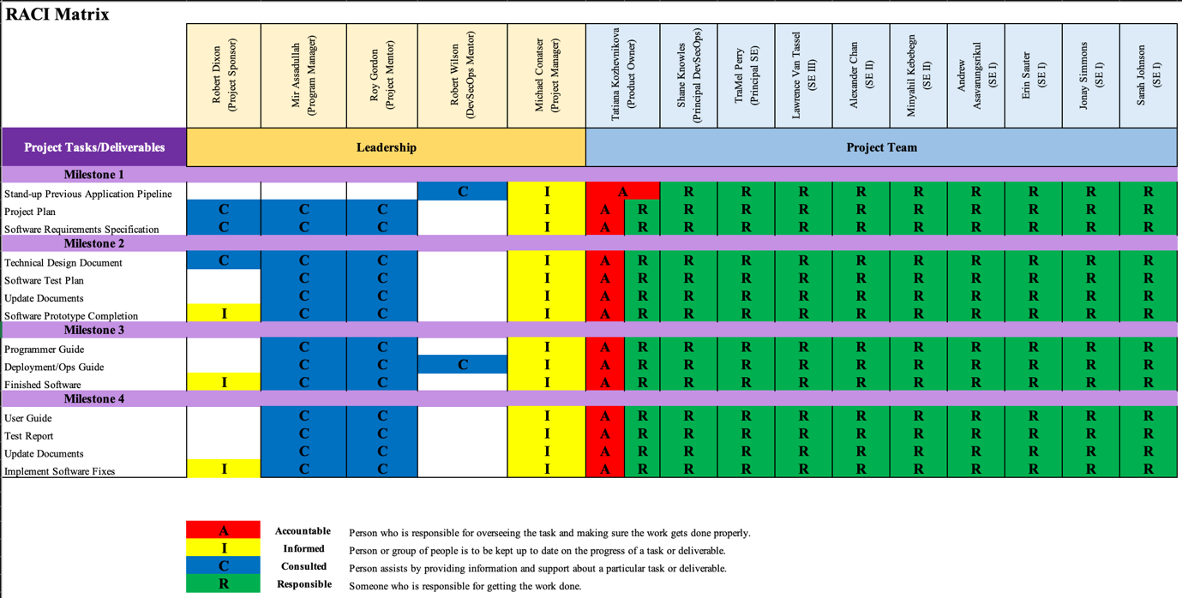

Figure 6.1 - RACI Matrix

Table 6.1 - Resources and Responsibilities

| Resource | Role | Responsibilities |
| --- | --- | --- |
| Dr. Mir Assadullah | Program Manager | * Provides business context, expertise, and guidance to the project manager and the team. * Provide guidance and make decisions for issues that are beyond the authority of the project manager * Acts as the link between the project, the business, and strategic level decision-making groups |
| Roy Gordon  Robert Wilson | Project Mentor | * Provide guidance and advisory for any impediments, issues and improvements |
| Michael Conatser | Project Manager  Scrum Master | * Provide project guidance for the project team. * Provide guidance to ensure project success. * Ensure project remains on schedule and on budget and bring to attention any risks/issues that may impact the team. |
| Erin Sauter  Jonay Simmons  Andrew Asavarungsrikul  Sarah Johnson | SE I | * Develop and unit test requirements using Capstone-specified programming languages and tools * Prepare Project Plan, Software Requirement Specification, and other required documents. |
| Alexander Chan  Minyahil Kebebegn | SE II |
| Lawrence Van Tassel | SE III |
| TraMel Perry  Shane Knowles | Principal SE |
| Tatiana Kozhevnikova | Product Owner | * Manage and prioritize the project backlog * Serve as a liaison between product and development * Evaluate project progress |

# Communications Management

Team B’s communication management plan anticipates that all stakeholders communicate frequently and that any issues and requests are acknowledged and satisfied promptly. This communication plan identifies communication channels and their purpose to provide effective project coordination.

## Microsoft Teams

MS Teams environment will be utilized as the main communication channel for effective and centralized information exchange. Teams’ channels should be used according to their purpose, and project-related tags should be used to quickly connect with the subset of people on the team.

Table 7.1 - MS Teams Tags

| Tag | People |
| --- | --- |
| @Team A | Team members of Team A |
| @Team B | Team members of Team B |
| @Customer | Dr. Mir Assadullah and Roy Gordon |
| @Project Manager | Mike Conatser |
| @DevSecOps | Shane Knowles, Mike Conatser, Robert Wilson and Johnny Lockhart |
| @Product Owners | Tatiana Kozhevnikova and Christopher Thorn |

* **MS Teams Channels:**
* *General.*

Utilized for all project-related communication that applies to members of Team A and Team B.

* *Team B Channel.*

Used as Team B’s communication and working directory.

* *Team B Stand-up.*

Utilized to share daily activity plan and project progress. All posted stand-up activities are organized in the tabular view in the Stand-up Meeting Tracking Sheet which is located under the Files tab in Team B Stand-up.

Table 7.2 - Channels’ Tabs

| Channel | Tab | Purpose |
| --- | --- | --- |
| General | Posts | Communication of project-related information that applies to both teams (Team A and Team B). |
| Files | Project-related documents, meeting recordings and reports. |
| Wiki | Useful project-related links. |
| Google Calendar | All scheduled project-related items and team members’ unavailability to attend scheduled meetings (main concern major review meetings). |
| GitHub | Current project’s GitHub repository. |
| Team B Channel | Posts | Communication of project-related information among Team B’s members. |
| Files | Team B’s project-related documents and milestone deliverables. |
| Wiki | Useful Team B’s links |
| Backlog | Team B’s GitHub backlog. |
| Team B Standup | Posts | Team members’ daily activity report and planning. |
| Files | Files related to the stand-up meetings. |
| Wiki | Links related to stand-up meetings |

* **MS Teams Meetings**

Teams Meeting feature will be used to hold the team’s video conferences. Meetings will be scheduled and recorded by Robert Wilson upon request or according to the pre-set schedule.

Table 7.3 - Meeting Types and Schedule

| Meeting Type | Frequency | Date and Time | Description |
| --- | --- | --- | --- |
| Team Planning | Weekly | Sundays at 4PM ET | Held to address and resolve project-related issues, set expectations for the upcoming week and suggest any improvements. |
| Customer Sync | Weekly | Mondays at 7PM ET | Held between the Project Mentor and Project Manager to discuss questions and issues. EVM reports will be emailed to the Project Sponsor and any customer questions will be emailed to the customer on the same schedule as this meeting. |
| Milestone Review Dry-Run | Custom | * 9/2 Friday at 7PM ET * 9/16 Friday at 7PM ET * 10/28 Friday at 7PM ET * 11/4 Friday at 7PM ET | Held as a trial to resolve any issues left before each formal presentation. |
| Milestone Review | Custom | * 9/3 Saturday at 1PM ET * 9/17 Saturday at 1PM ET * 10/29 Saturday at 1PM ET * 11/5 Saturday at 1PM ET | Held to present milestone deliverables to the customer. |

## GitHub

GitHub will be used to coordinate an effort in issue tracking and application development. Team members are expected to monitor the backlog, self-assign tasks based on the priorities of the current milestone and update the status of the task to communicate progress.

## Email

Email communication can be used to establish contact with some of the stakeholders who are not on Microsoft Teams. The project manager will direct all email communications to avoid any confusion.

# Risk Management

Risk management includes risk management planning, identification, analysis, response planning, and monitoring and control. The project team will address any anticipated potential problems through risk identification and mitigation efforts. These activities are continuous throughout the MSA project service delivery process, starting with initial project planning and continuing to project completion and close out. Our Risk Management process is shown in the Risk Management Process diagram below and revolves around the following activities.

* Identify the Risks: Understand the concerns of team members and the possible events that could occur during program execution. This effort is done during the project planning process.
* Assess the Risks: Rank the risks based on probability of occurrence and impact of occurrence. Determine risk response (avoidance, mitigation, or acceptance) develop mitigation strategies and contingency plans for them. Qualitative and quantitative analysis of the risks is part of this effort and is done during the project planning process.
* Control the Risks: Execute mitigation strategies. Should a risk occur, execute the contingency plan.
* Monitor the Risks: Continuously revisit the risk profile and update as needed. Re-evaluate risks on a schedule. Document and track risks and resolution on the risk register.

Figure 8.1 - Continuous Risk Management Process from Planning Through Close Out. Adapted from ‘risk-process_USDA-FSIS-e-Device_015’, by Governance & Information Management Branch, 2016, Enterprise Process Lifecycle.

The project team will identify, assess, control, and monitor risks. This includes descriptions of risks and corresponding mitigation actions that have been identified to guide the risk reduction efforts. The team’s risk assessment helps to identify the potential impact of changes and other task modifications to ensure stakeholders are informed regarding process, issue resolution, and project outcome.

The project manager will maintain a master Risk Register (Appendix C) to catalogue identified risks and their potential impacts. This information will be presented in the weekly status meetings or on-demand as requested by management and stakeholders. If an identified risk is determined to be Priority One (Urgent), it is immediately reported to management. The Risk Owner will be responsible for updating the risk assessment results in the Risk Register. The Risk Owner and PM work jointly to develop and document mitigation strategies. The following subsection will further describe the details for each major activity.

## Risk Analysis

All risks identified will be assessed to identify the range of possible project outcomes. Risks will be prioritized by their level of importance using a qualitative risk analysis approach. This approach will use the probability and impact of occurrence for each identified risk and will be assessed by the project manager, with input from the project team using the following guidelines:

**Probability**

* High – Greater than 70% probability of occurrence
* Medium – Between 30% and 70% probability of occurrence
* Low – Below 30% probability of occurrence

**Impact**

* High – Risk that has the potential to greatly impact project cost, project schedule or performance
* Medium – Risk that has the potential to slightly impact project cost, project schedule or performance
* Low – Risk that has relatively little impact on cost, schedule or performance

## Issue Management

An issue is defined as a problem that has occurred that may have an impact on the MSA project, or work to be performed, and may prevent the project from meeting customer requirements or the overall project objectives. An issue is usually an immediate problem and may arise from the occurrence of a triggered risk. Corrective action plans will be developed based on the following criteria:

* Scope changes
* Significant schedule variation
* Significant cost variation

Table 8.1 - Project Metrics

| Metric/Measurement | Collector | Distribution | Reporting Frequency | Analysis |
| --- | --- | --- | --- | --- |
| **Required Organizational Metrics** | | | | |
| Risk   1. Number of currently open risks, by priority (high, medium, low) 2. Total number of risks identified since project start up, by priority (high, medium, low) | Project manager | Senior management and customer | Weekly | Trend analysis to determine the project with higher levels of risk exposure; may require greater monitoring |
| Schedule   1. Actual versus baseline start and end dates, by milestone/deliverable | Product owner or team member directed by project manager | Senior management and customer | Weekly | Trend and variance analysis measuring the quality of work products and the frequency of quality monitoring  Analysis includes investigation of trends in the number of defects found |
| Requirements   1. Requirements management: Total number of changes made to the approved/ baseline requirements | Product owner | Senior management and customer | By milestone | Trend analysis to determine the projects whose scope changes over the life of the project |
| Validation   1. Total number of bugs/defects identified versus resolved during customer validation testing | Product owner | Senior management and customer | Release | Trend analysis to determine the project’s ability to meet stated customer needs and gain customer acceptance of deliverables |

# Compliance Related Planning

* This product will comply with Android Software Development Kit license.
* This product will comply with the New BSD license for application development using the Flutter UI development kit.
* If it is determined that this application shall be published to the Google Play platform, the organization shall acquire an Android developer license and comply with its terms and conditions.
* The organization shall acquire an Apple developer license and comply with its license terms and conditions.
* The organization shall acquire a Google developer license and comply with its license terms and conditions.
* This product shall comply with Syncfusion Community License Program by agreeing to Syncfusion’s terms and conditions. The license shall be upgraded to Commercial type if:
* the number of developers within the organization is five or more;
* the gross revenue exceeds one million U.S. dollars.
* This product will comply with all licensing requirements from any third-party organizations with which the application interfaces.
* This product is not intended to be publicly available through any application distribution platform during the course of this project and, therefore, shall not be subject to licensing requirements for any application distribution platform.
* This product will adhere to the terms and conditions presented to the end user.
* This product shall require users to acknowledge their understanding of its privacy and security policy.
* This product will comply with United States privacy laws regarding data privacy rights. This product does not permanently store any user data, including credentials used for accessing users’ email accounts and users’ email data. This product will anonymize any user data shared with any third-party organization.

Appendix A - Acronyms and Definitions

| Term | Meaning |
| --- | --- |
| AI | Artificial Intelligence |
| A-SDLC | Agile - Software Development Lifecycle |
| AOSP | Android Open-Source Project |
| BSD | Berkeley Software Distribution |
| CCB | Change Control Board |
| DevSecOps | Development, Security, & Operations |
| EVM | Earned Value Management |
| IMS | Integrated Master Schedule |
| iOS | iPhone Operating System |
| KPI | Key Performance Indicators |
| MS | Microsoft |
| MSA | MailSpeak Application |
| OCR | Object Character Recognition |
| PM | Project Manager |
| PMP | Project Management Plan |
| RACI | Responsible, Accountable, Consulted, Informed |
| SDLC | Software Development Lifecycle |
| SE | Software Engineer |
| SRS | Software Requirements Specification |
| SWEN | Software Engineering |
| TBD | To Be Determined |
| UI | User Interface |
| UMGC | University of Maryland Global Campus |
| USPS | United States Postal Service |
| V1 | Version 1 |
| V2 | Version 2 |
| WBS | Work Breakdown Structure |

Appendix B – Detailed Project Schedule

Figure 10.1 - Detailed Project Schedule (Part 1)

Figure 10.2 - Detailed Project Schedule (Part 2)

Figure 10.3 - Detailed Project Schedule (Part 3)

Figure 10.4 - Detailed Project Schedule (Part 4)

Figure 10.5 - Detailed Project Schedule (Part 2)

Appendix C - Risk Register

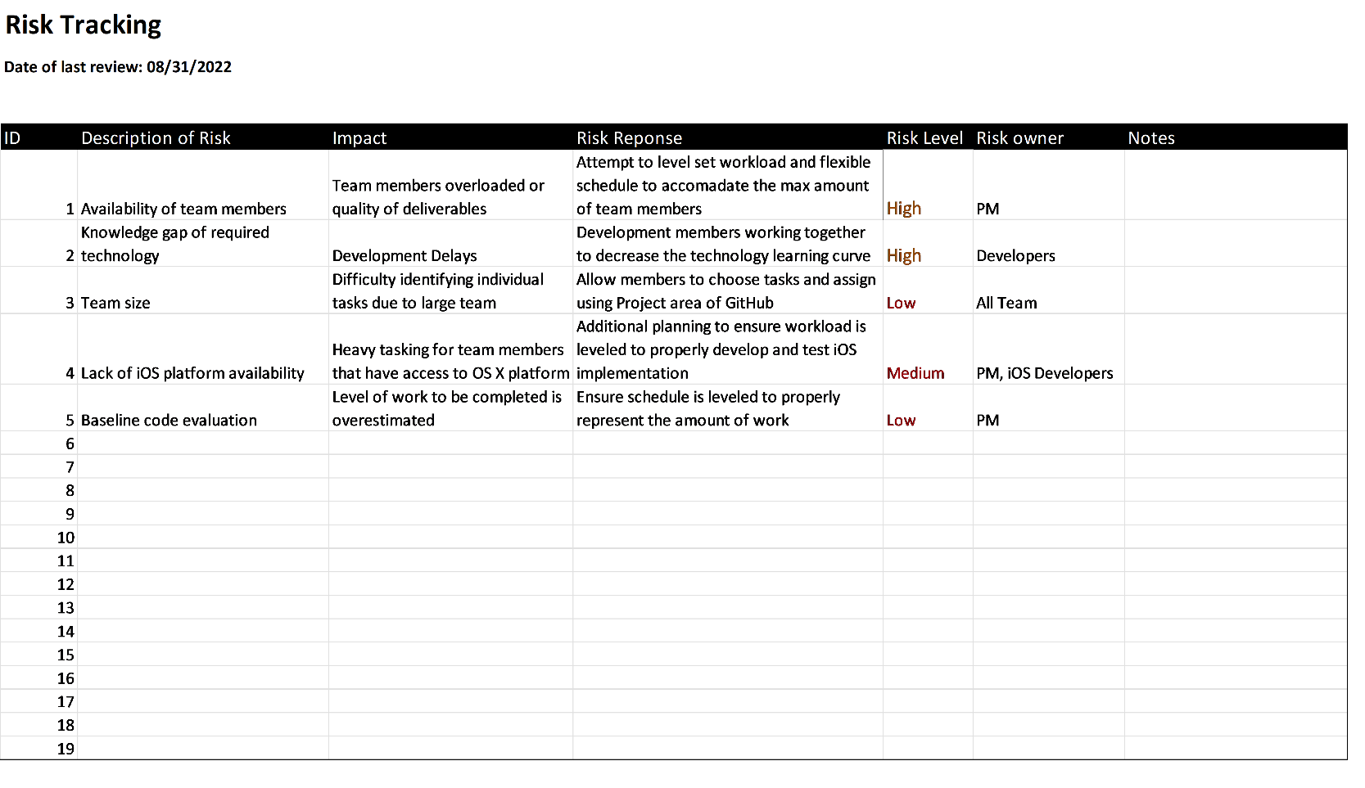

Figure 10.6 – Master Risk Register

Appendix D - References

Governance & Information Management Branch. (2016). *Continuous Risk Management Process from Planning Through Close Out* [Digital image]